Submitted To:

Engineer Sheharyar Khan

Name: Iqra Fatima

Reg. Number: 23-CP-62

Semester: 4th

Department: CPED

Data Structures and Algorithms

(DSA)  
Lab Report 5

Obtained Marks: Not Evaluated Total Marks: 8

**Marks Distribution:**Total Lab Activity Marks:4   
Total Lab Report Marks: 4

Lab 5

**Guided Tasks (Doubly Linked List)**

**Task 1:** Implementing a Doubly Linked List (DLL)

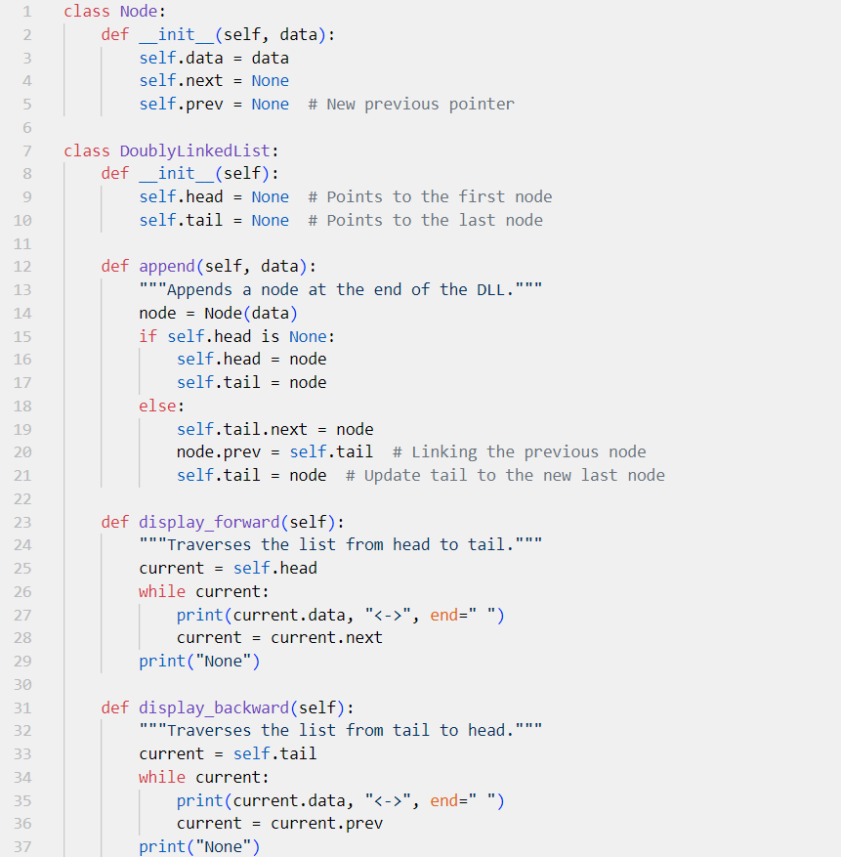

**Output:**



**Task 2:** Insertion Operations in DLL

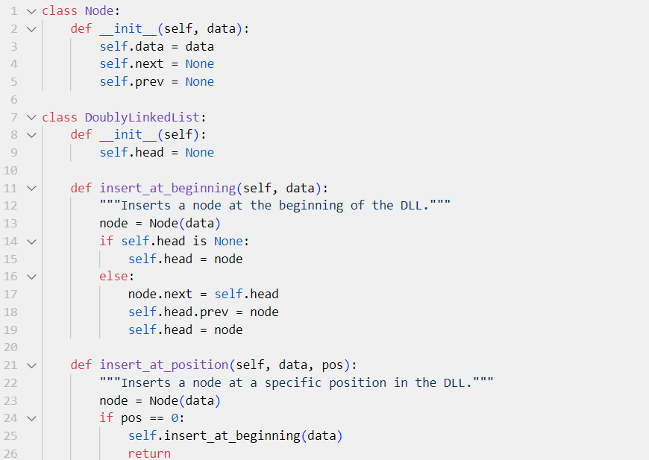

**Output:**



**Task 3: Music Playlist System using a Doubly Linked List**

**Output:**

**EXERCISE**

**Easy Problems**

**1-DLL Basic Operations**

Implement a class for Doubly Linked List that supports append, display, and delete from start.

**class Node:**

**def __init__(self, data):**

**self.data = data**

**self.prev = None**

**self.next = None**

**class DoublyLinkedList:**

**def __init__(self):**

**self.head = None**

**def append(self, data):**

**new_node = Node(data)**

**if not self.head:**

**self.head = new_node**

**return**

**temp = self.head**

**while temp.next:**

**temp = temp.next**

**temp.next = new_node**

**new_node.prev = temp**

**def display(self):**

**temp = self.head**

**while temp:**

**print(temp.data, end=" <-> ")**

**temp = temp.next**

**print("None")**

**def delete_from_start(self):**

**if not self.head:**

**print("List is empty")**

**return**

**self.head = self.head.next**

**if self.head:**

**self.head.prev = None**

**# Usage**

**dll = DoublyLinkedList()**

**dll.append(10)**

**dll.append(20)**

**dll.append(30)**

**dll.display()**

**dll.delete_from_start()**

**dll.display()**

**Output:**



**2. DLL Reverse Traversal**

Implement a method to print a DLL in reverse order.

**class Node:**

**def __init__(self, data):**

**self.data = data**

**self.next = None**

**self.prev = None**

**class DoublyLinkedList:**

**def __init__(self):**

**self.head = None**

**def append(self, data):**

**new_node = Node(data)**

**if not self.head:**

**self.head = new_node**

**return**

**temp = self.head**

**while temp.next:**

**temp = temp.next**

**temp.next = new_node**

**new_node.prev = temp**

**def reverse_traverse(self):**

**temp = self.head**

**if not temp:**

**print("List is empty")**

**return**

**while temp.next:**

**temp = temp.next**

**while temp:**

**print(temp.data, end=" <-> ")**

**temp = temp.prev**

**print("None")**

**# Usage**

**dll = DoublyLinkedList()**

**dll.append(10)**

**dll.append(20)**

**dll.append(30)**

**dll.reverse_traverse()**

**Output:**



**3. DLL Length Calculation**

Implement a function that returns the length of a DLL.

**class Node:**

**def __init__(self, data):**

**self.data = data**

**self.next = None**

**self.prev = None**

**class DoublyLinkedList:**

**def __init__(self):**

**self.head = None**

**def append(self, data):**

**new_node = Node(data)**

**if not self.head:**

**self.head = new_node**

**return**

**temp = self.head**

**while temp.next:**

**temp = temp.next**

**temp.next = new_node**

**new_node.prev = temp**

**def get_length(self):**

**count = 0**

**temp = self.head**

**while temp:**

**count += 1**

**temp = temp.next**

**return count**

**# Usage**

**dll = DoublyLinkedList()**

**dll.append(10)**

**dll.append(20)**

**dll.append(30)**

**print("Length:", dll.get_length())**

**Output:**



**Intermediate Problems**

**1. Game Leaderboard (DLL)**

Implement a leaderboard where scores are stored in a Doubly Linked List, sorted by highest score.

**class Node:**

**def __init__(self, name, score):**

**self.name = name**

**self.score = score**

**self.next = None**

**self.prev = None**

**class Leaderboard:**

**def __init__(self):**

**self.head = None**

**def add_score(self, name, score):**

**new_node = Node(name, score)**

**if not self.head or self.head.score < score:**

**new_node.next = self.head**

**if self.head:**

**self.head.prev = new_node**

**self.head = new_node**

**return**

**temp = self.head**

**while temp.next and temp.next.score >= score:**

**temp = temp.next**

**new_node.next = temp.next**

**if temp.next:**

**temp.next.prev = new_node**

**temp.next = new_node**

**new_node.prev = temp**

**def display_leaderboard(self):**

**temp = self.head**

**while temp:**

**print(f"{temp.name}: {temp.score}")**

**temp = temp.next**

**# Usage**

**board = Leaderboard()**

**board.add_score("Alice", 85)**

**board.add_score("Bob", 92)**

**board.add_score("Charlie", 78)**

**board.display_leaderboard()**

**Output:**

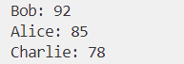

**Advanced Problems**

**1. Facebook Messenger Chat History (DLL)**

Implement a chat history feature using a Doubly Linked List to navigate through messages.

**class Node:**

**def __init__(self, message):**

**self.message = message**

**self.next = None**

**self.prev = None**

**class ChatHistory:**

**def __init__(self):**

**self.head = None**

**self.tail = None**

**def add_message(self, message):**

**new_node = Node(message)**

**if not self.head:**

**self.head = new_node**

**self.tail = new_node**

**else:**

**self.tail.next = new_node**

**new_node.prev = self.tail**

**self.tail = new_node**

**def show_history(self):**

**temp = self.tail**

**while temp:**

**print(temp.message)**

**temp = temp.prev**

**# Usage**

**chat = ChatHistory()**

**chat.add_message("Hello")**

**chat.add_message("How are you?")**

**chat.add_message("I'm good, thanks!")**

**chat.show_history()**

**Output:**

**2. Undo/Redo System (DLL)**

Implement an Undo/Redo system for a text editor using Doubly Linked Lists.

**class Node:**

**def __init__(self, text):**

**self.text = text**

**self.next = None**

**self.prev = None**

**class TextEditor:**

**def __init__(self):**

**self.head = None**

**self.current = None**

**def write(self, text):**

**new_node = Node(text)**

**if not self.head:**

**self.head = new_node**

**self.current = new_node**

**else:**

**new_node.prev = self.current**

**self.current.next = new_node**

**self.current = new_node**

**def undo(self):**

**if self.current and self.current.prev:**

**self.current = self.current.prev**

**print("Current Text:", self.current.text if self.current else "Empty")**

**def redo(self):**

**if self.current and self.current.next:**

**self.current = self.current.next**

**print("Current Text:", self.current.text if self.current else "Empty")**

**# Usage**

**editor = TextEditor()**

**editor.write("Hello")**

**editor.write("World")**

**editor.undo()**

**editor.redo()**

**Output:**



**3. Browser History Navigation (DLL)**

Implement forward and backward navigation in a web browser using a Doubly Linked List.

**class Node:**

**def __init__(self, url):**

**self.url = url**

**self.next = None**

**self.prev = None**

**class BrowserHistory:**

**def __init__(self):**

**self.current = None**

**def visit(self, url):**

**new_node = Node(url)**

**if not self.current:**

**self.current = new_node**

**else:**

**new_node.prev = self.current**

**self.current.next = new_node**

**self.current = new_node**

**def back(self):**

**if self.current and self.current.prev:**

**self.current = self.current.prev**

**print("Current Page:", self.current.url if self.current else "No history")**

**def forward(self):**

**if self.current and self.current.next:**

**self.current = self.current.next**

**print("Current Page:", self.current.url if self.current else "No forward history")**

**# Usage**

**browser = BrowserHistory()**

**browser.visit("google.com")**

**browser.visit("facebook.com")**

**browser.back()**

**browser.forward()**

**Output:**

